You and your partner will guess each other's letters, using only Spanish numbers.
Hit: Sí, lo tengo. Miss: No, no lo tengo.
Draw a letter with a highlighter on the chart labeled "Mi letra," below. It can be big or small.
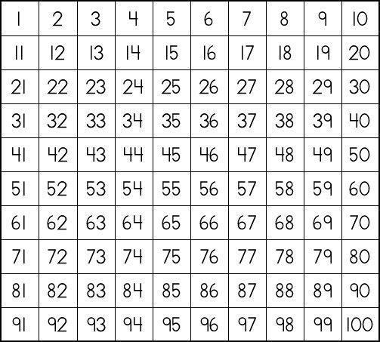
Mi letra

Keep track of your partner's letter on the grid below. Use X's for sí and O's for no.
La letra de mi pareja

