Nombre: _____________________________ Fecha: _________________ Hr.: __
Los "Pretérit-Os"
You are the new employee in charge of design at the Spanish cereal factory. Your boss has told you that Pretérit-Os is in need of a new look.
You will be creating a new design example on a cereal box, much like the ones shown below.
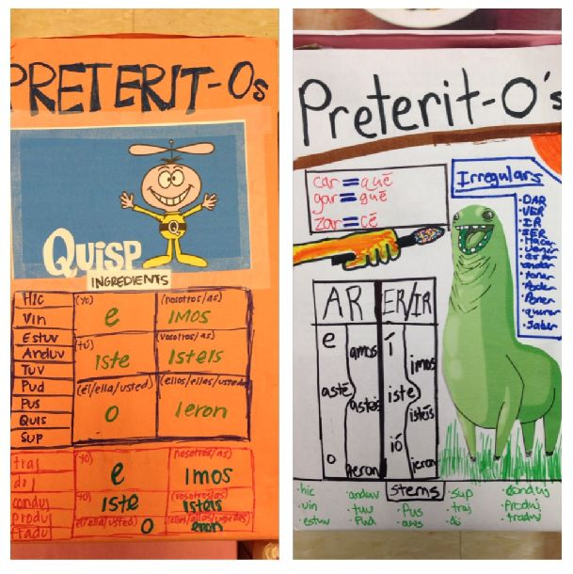
Your design must meet the following requirements:
On the front and sides:
1. all regular -ar verb endings (6 points)
2. at least 4 regular -ar verb ending examples (4 points)
3. all regular -er and -ir verb endings (6 points)
4. at least 4 regular -er and -ir verb ending examples (4 points)
5. all conjugations of at least 2 of the following: ir/ser, hacer, ver and dar (12 points)
6. at least 3 words that indicate the past (ex. yesterday, last year, etc.) (3 points)
On the back:
1. two games to practice using the preterite (5 points each)
Total: 45 x 2 = 90 points
*Your design should be colorful and neat. You will turn in an actual cereal box for PretéritOs.
Each error, spelling or otherwise, will result in an 1/2 point deduction.

